Military Ridge State Trail – General Operations
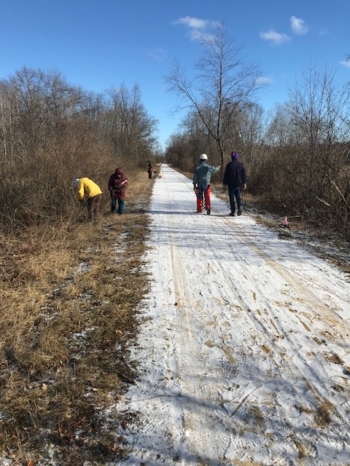
The staff and volunteers of the Military Ridge State Trail (MRT) share a common operation goal to provide a safe and memorable recreation experience to all visitors who use the trail. Whether you are jogging, biking, hiking or snowmobiling, we strive to efficiently manage the 40 miles (approx. 490 acres) of trail Right-of-Way (ROW) that support multiple recreational opportunities.
Wisconsin State Trails, such as the MRT, are designed with a minimum 10-foot-wide crushed limestone trail surface to allow for safe two-way traffic. We work to maintain a 16 to 18-foot overhead clearance to allow for emergency vehicles, tractors and snow grooming equipment. This clearance also lets more sunlight in to help dry the trail surface. The trail surface shoulders are mowed 6-feet-wide to allow for better sightlines and wider “pull off” areas.
In general, the Military Ridge State Trails’ Right-of-Way (ROW) is managed as a nature preserve to provide a natural setting for trail users and habitat for wildlife. The management of the trail’s vegetation, including wildflowers, shrubs and trees, has become more challenging as existing and newly introduced invasive species rapidly grow along the ROW and crowd out desirable species. Park staff and volunteers use a variety of hand tools, power equipment, herbicide and machinery to help manage the trail’s vegetation.
Friends of Military Ridge State Trail work day cutting brush along the trail
Mowing
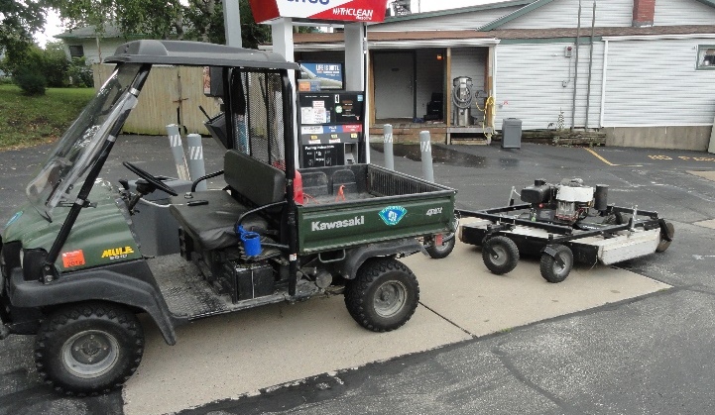
A 4-foot-wide finish mowing of the shoulders is completed along the entire length of the trail approximately every 4 weeks when conditions allow. This is accompanied by additional trimming of vegetation at bridges, sign posts and intersections. The finish mower is a towable mower pulled by a utility vehicle. This process keeps the vegetation from blocking signage.
Once a year, usually late summer or fall, the staff performs a 6 to 10-foot-wide rough cut brush mowing along the trail shoulders for the entire length of the trail. This helps set back encroaching woody shrubs (e.g. buckthorn, honeysuckle) and trims off new growth of woody stems that could grow and crowd the trail surface in the future. It is more efficient to mow a ½ inch woody stem each year than to cut an invasive tree down every few years.
UTV and finish mower fueling up along the trail
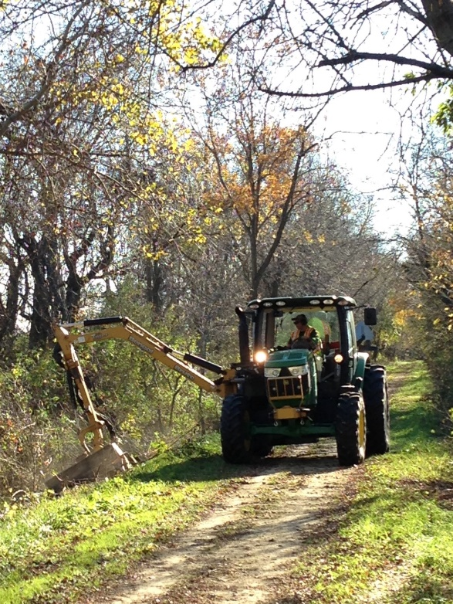
Brushing
Each fall/winter a specific area of the trail is selected to aggressively clear back vegetation and open up the ROW to reclaim the trail corridor. The areas selected are usually narrowed by excessive or long term growth of invasive shrubs and trees. We use a larger tractor with one or more mowing attachments with an extendable mowing head. The volunteer group, Friends of Military Ridge State Trail, works on selected areas to remove trees and brush to open scenic vistas and rest areas for the public to enjoy. Staff and volunteers also use hand and power tools to cut around desirable tree species such as oaks, hickories and maples.
Herbicides are used primarily to treat cut stumps of non-desirable and invasive trees and shrubs. This helps prevent re-sprouting. On occasion herbicides are applied to newly discovered invasive plants encroaching on the trail tread.
Tractor with boom arm mower
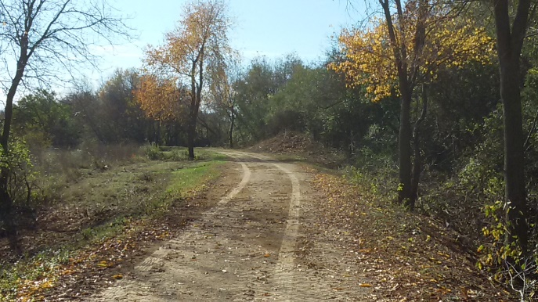
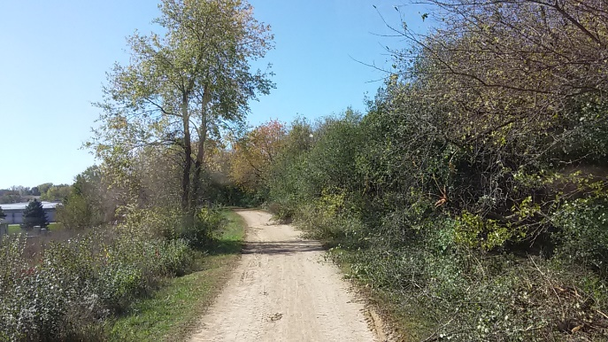
Before
After
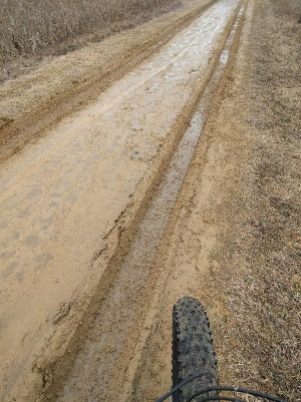
Trail Tread Maintenance
We maintain the trail tread with a small utility vehicle and pickup truck pulling a blade grader and heavy roller to grade and roll the trail surface in spring. This equipment helps smooth ruts created by early season trail users or maintenance vehicles that caused damaged to the trail when the limestone surface was excessively wet or thawing from the winter. This equipment is used throughout the warm season to help repair mild to moderate trail surface damage caused by storms, livestock and vehicles. Staff work to repair washouts, sink holes and animal burrows that show up throughout the season.

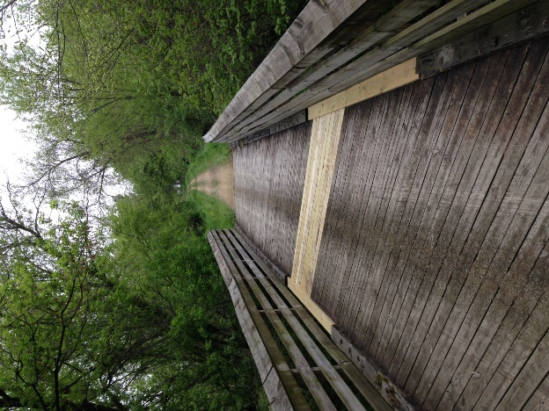
Bridges, Tunnels and More
Trail kiosks, interpretive signs, benches, picnic tables, bridge decking and railings are inspected semi-annually. Repairs are prioritized with safety issues taking precedent over aesthetics. Repairs are made until a larger re-decking or replacement project is necessary and available. Tunnels, culverts and bridge substructures are inspected annually by trained inspectors. Repairs are scheduled based on inspection reports.
Beginning in 2017, Bridges that are in good to excellent condition will have a “repurposed” rock quarry conveyor belting fastened to the center of the bridge to help protect the wood decking from the metal studs that are on some snowmobile tracks.
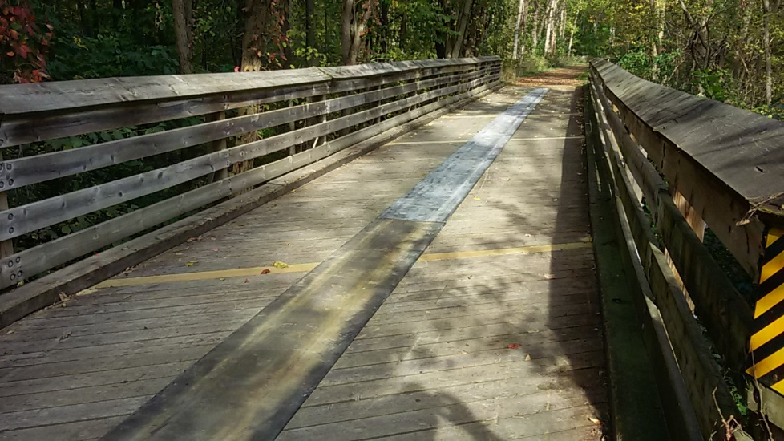

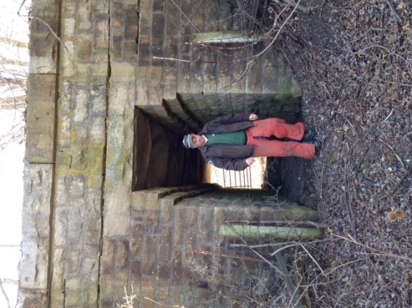
One of the many cattle crossing culverts under the trail that you might not have known existed!

The Military Ridge State Trail has 40 miles of trail tread, approximately 490 acres of ROW, 47 bridges and 3 box culvert tunnels. Each season presents new challenges and opportunities for improvements. We are grateful for the partnerships we have with volunteers, municipalities and you, the trail users, to keep things running smoothly. Please continue to be the eyes and ears of the trail and report any issues or concerns.
State Park and Trail Office: 608-437-5711

